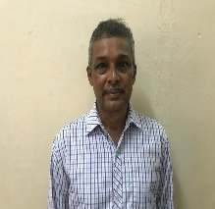
Name : VASUDEVA BHAT
Department : CHEMISTRY
College : Institute of Engineering &Technology
Contact Details : Mobile: 7483734114;
Email: bhatvasudeva2015@gmail.com

Educational Details:
- UG : B.Sc. (PCM), Poornapranja College, Udupi
- PG : M.Sc. (Chemistry, Inorganic), Mysore University
- Ph.D. : I.I.Sc., Bangalore, (Solid State and Structural Chemistry)
- P.D.F. : (1) Purdue University, USA, (2) Tokyo Inst. Tech., Japan

Teaching Experience : 15 Years
Research Experience : 10 Y Research Details:
- Research Area : Experimental Preparative Solid State Chemistry
- Funding sanctioned : ( if any)
- Publications : 20
- Conference/Workshops attended: 5
- Any other details :

